Scite.ai: Access and User Guide

Scite.ai- Smart Citation Database
https://scite.ai/assistant?utm_source=google&utm_medium=cpc&utm_campaign=brand&utm_term=scite%20ai&gad_source=1&gad_campaignid=19870517034&gbraid=0AAAAACSa0LI75OtJn6FLz_KvuU92m3DRf&gclid=CjwKCAjw3ejRBhAdEiwADkqPn4_-1dkCyyVTn28Sp_h8EJqACEqD_RbqlBWbv-xy9JT5U85OBtCYnxoC_vwQAvD_BwE

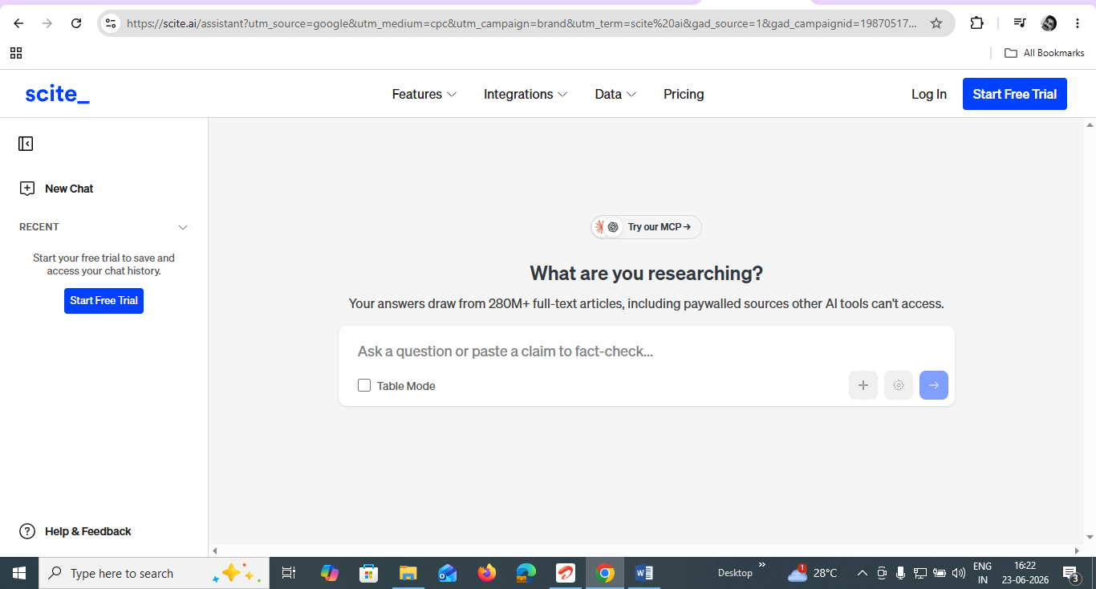

Step 1: Sign up with your official email and a Password on your own, with all the criteria required for the password
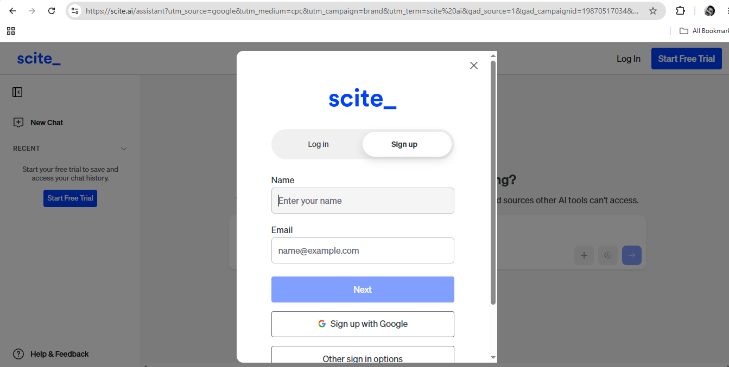

Step 2: After the Login page, click on Help & Feedback
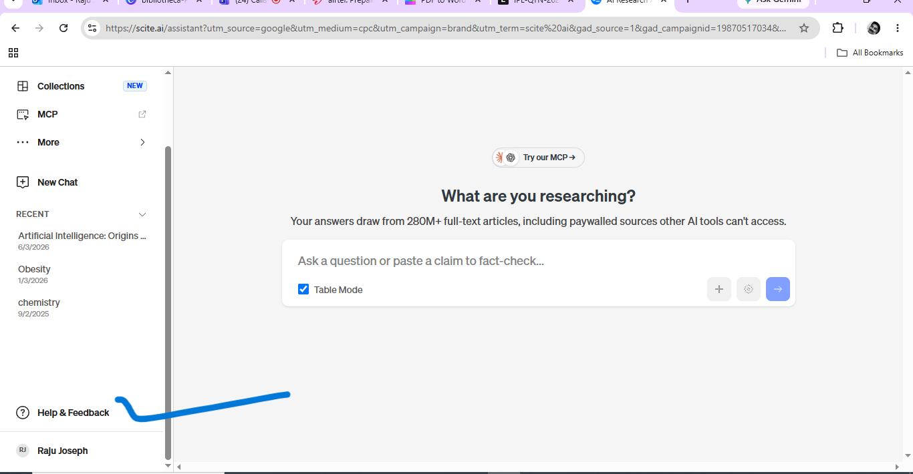

https://scite.ai/getting-started
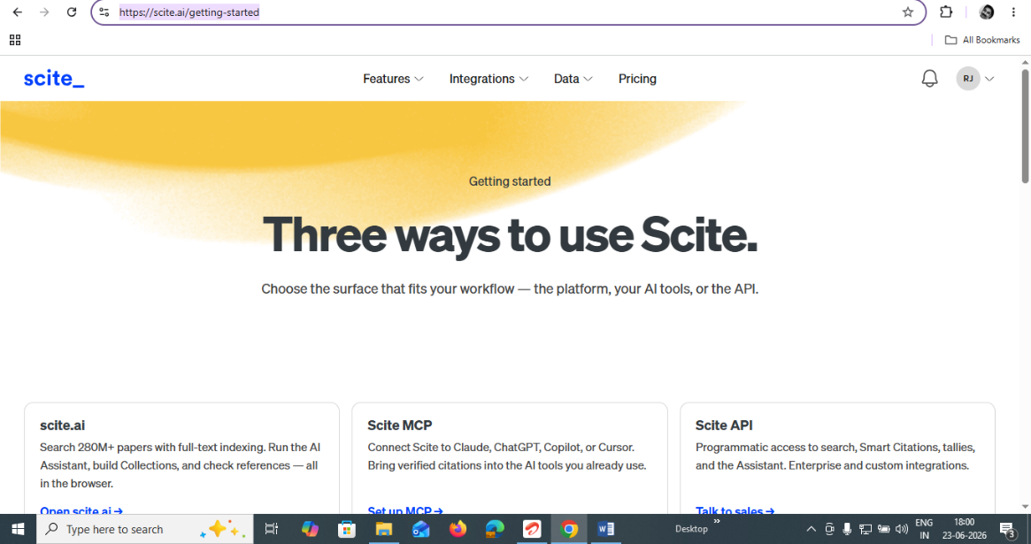

https://scite.ai/demos
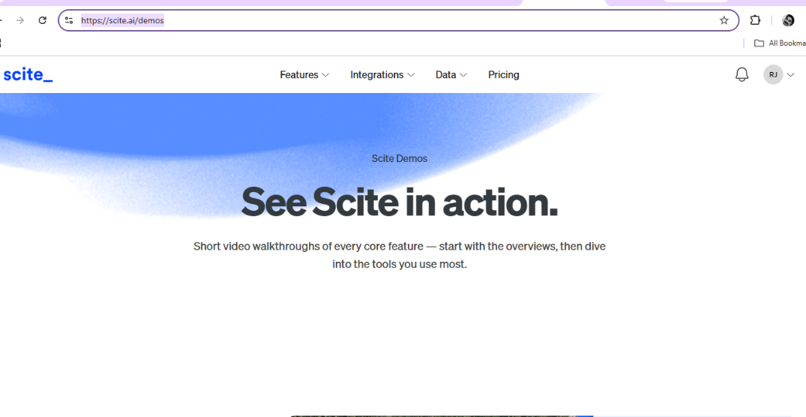

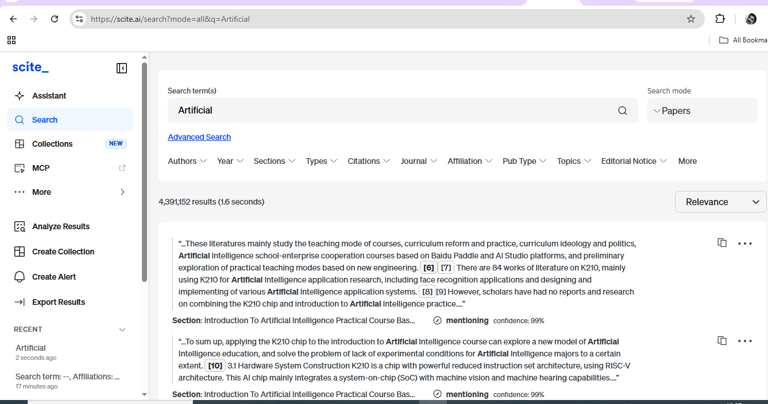

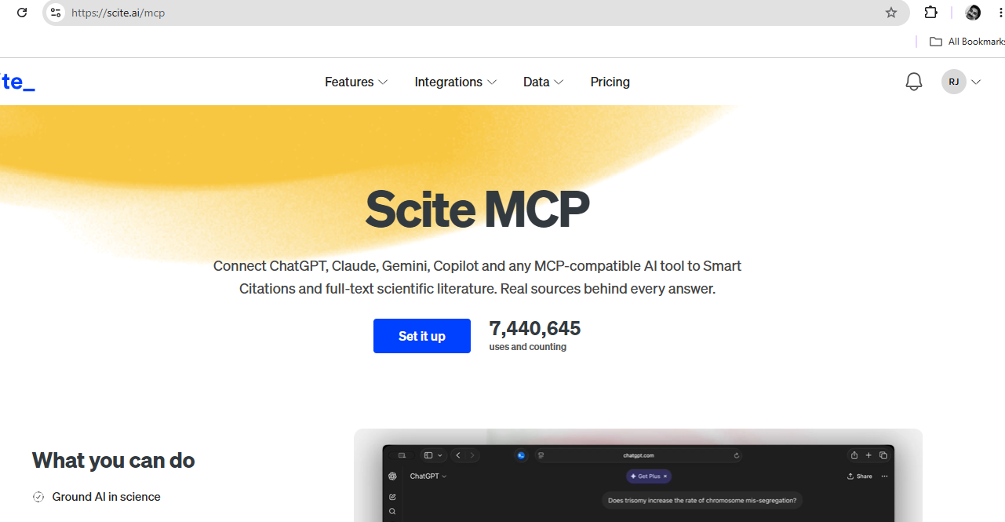

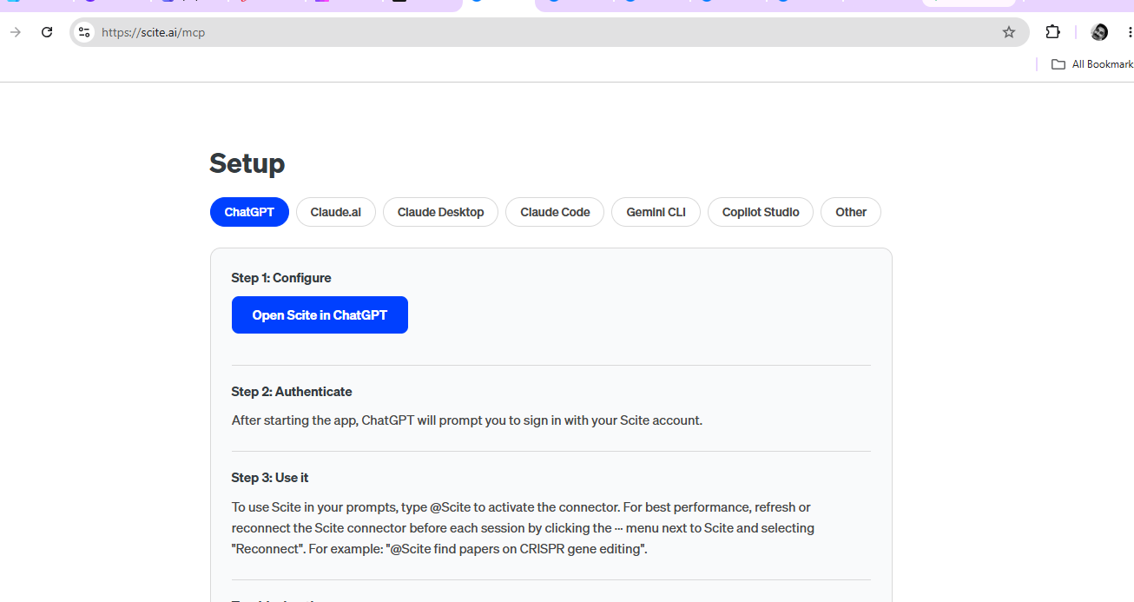

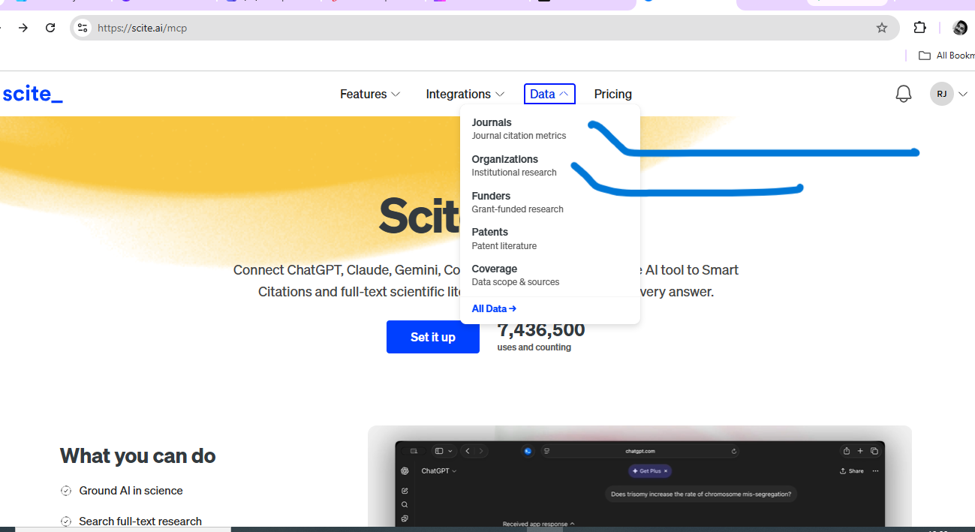

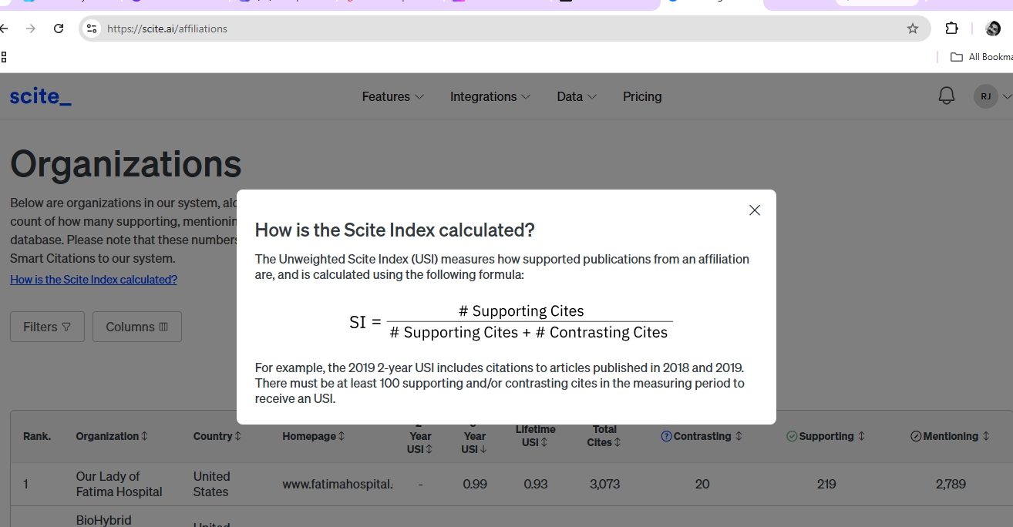

https://scite.ai/affiliations/manipal-academy-of-higher-education-0AmP
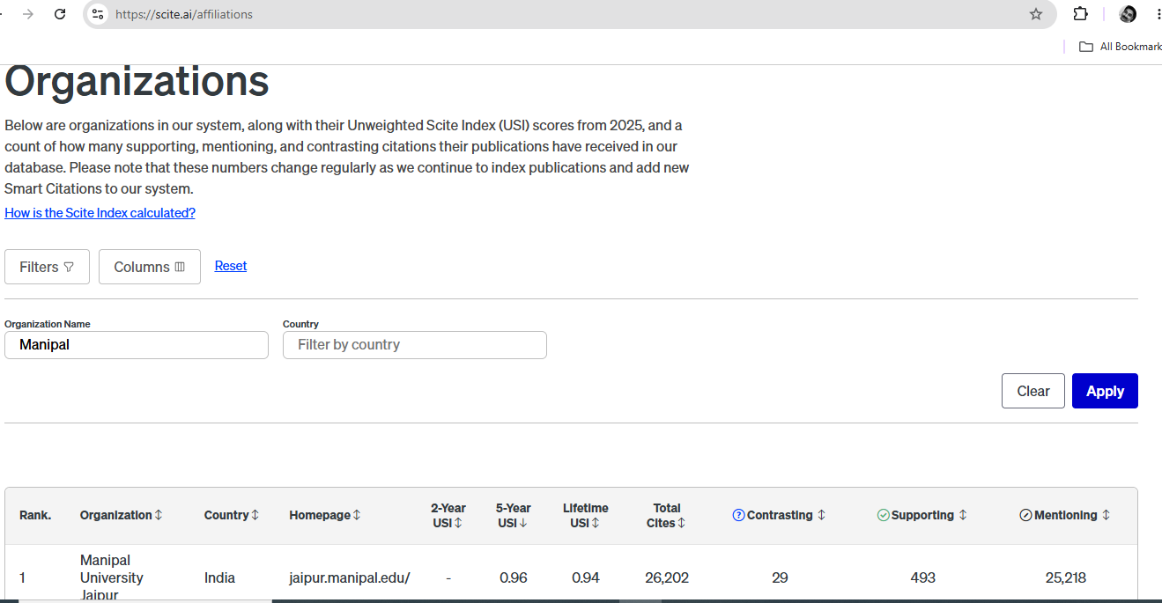

You can search for any institutions in the world
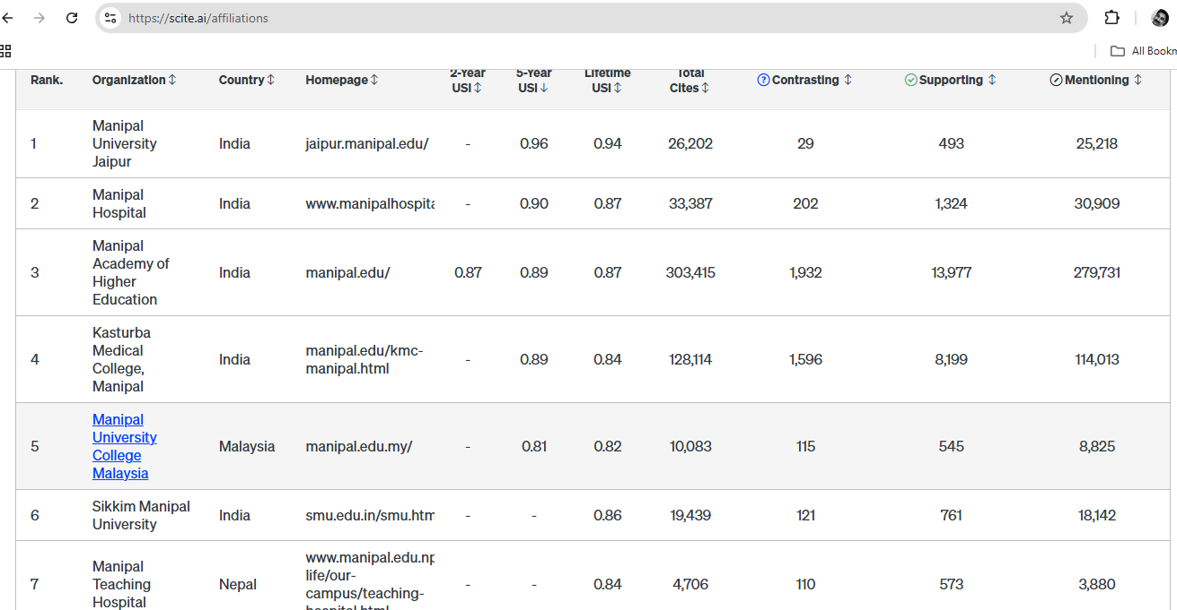

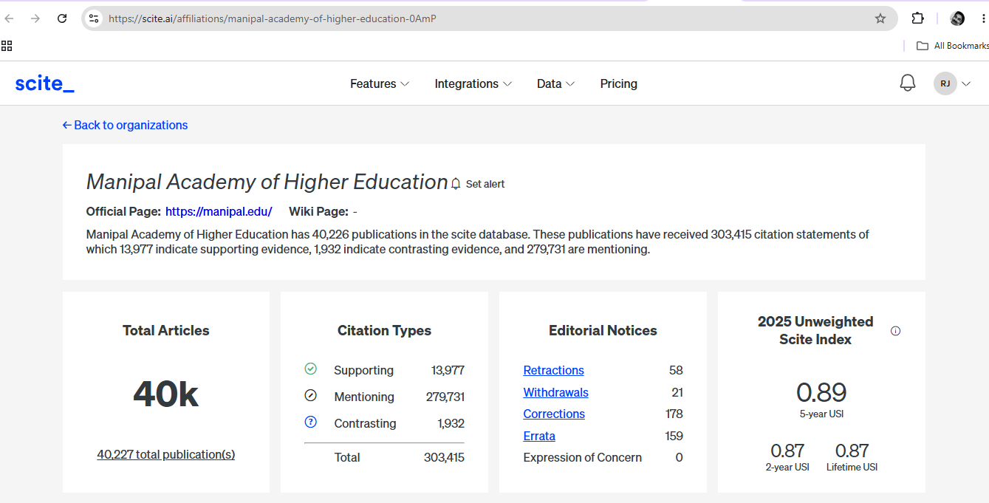

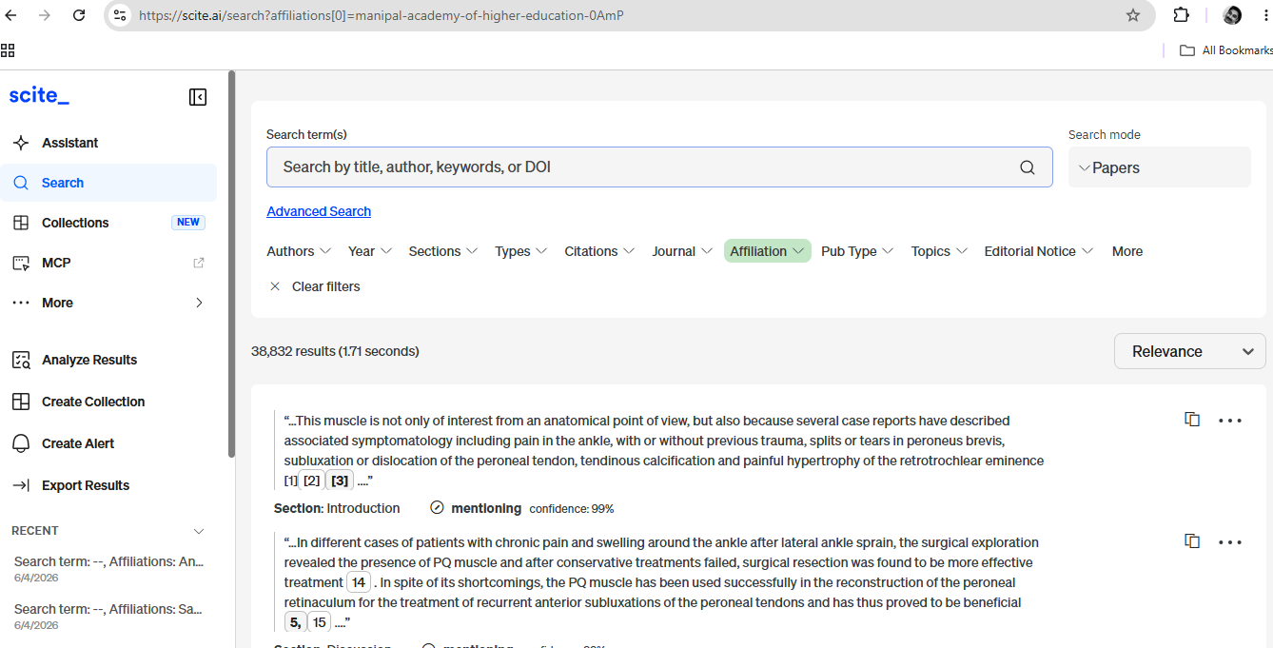

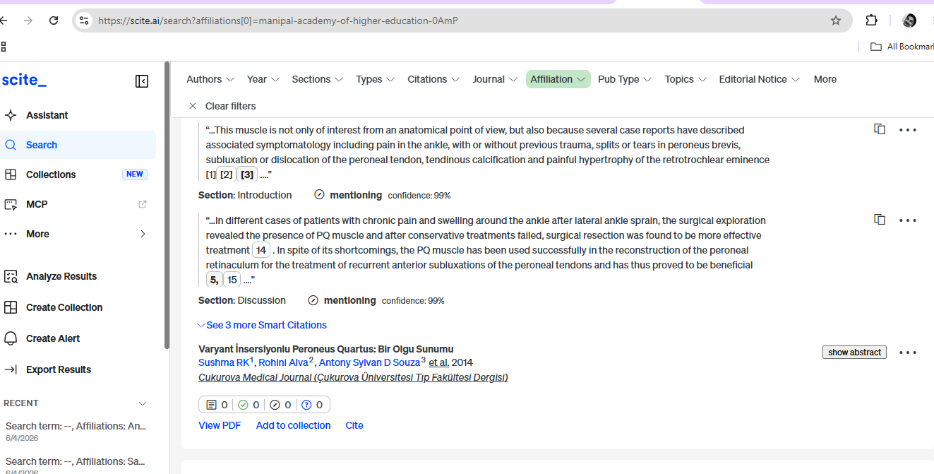

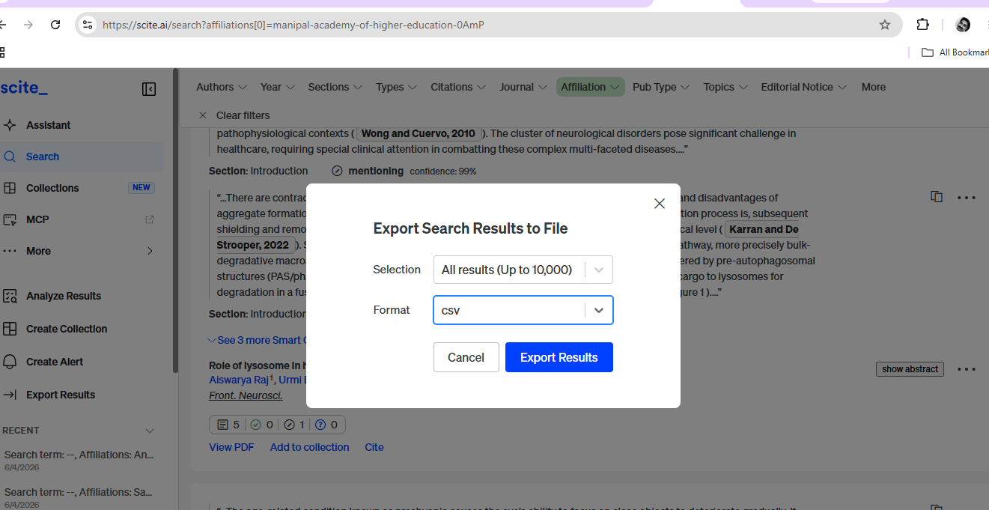

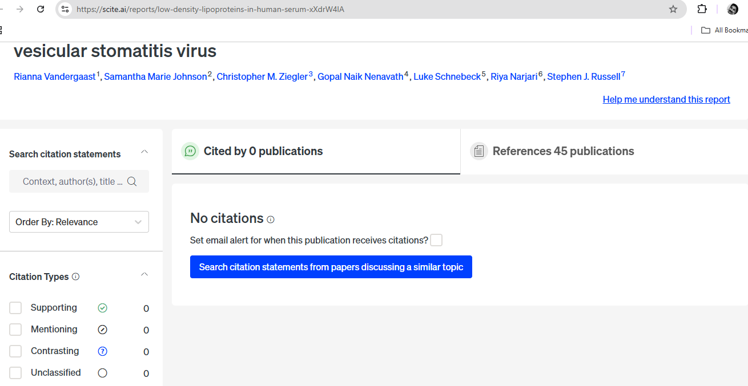

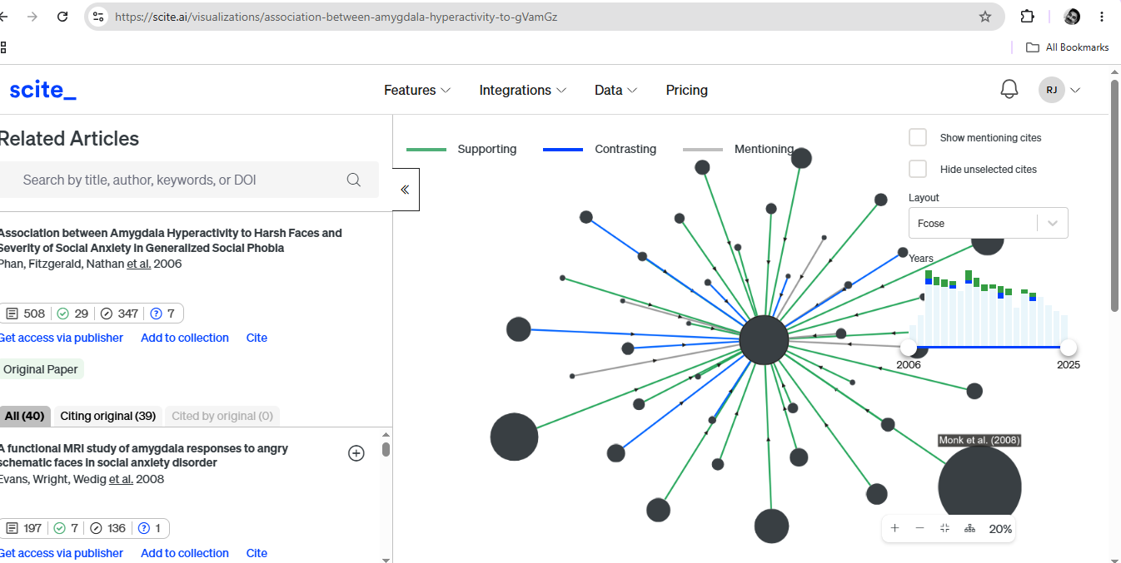

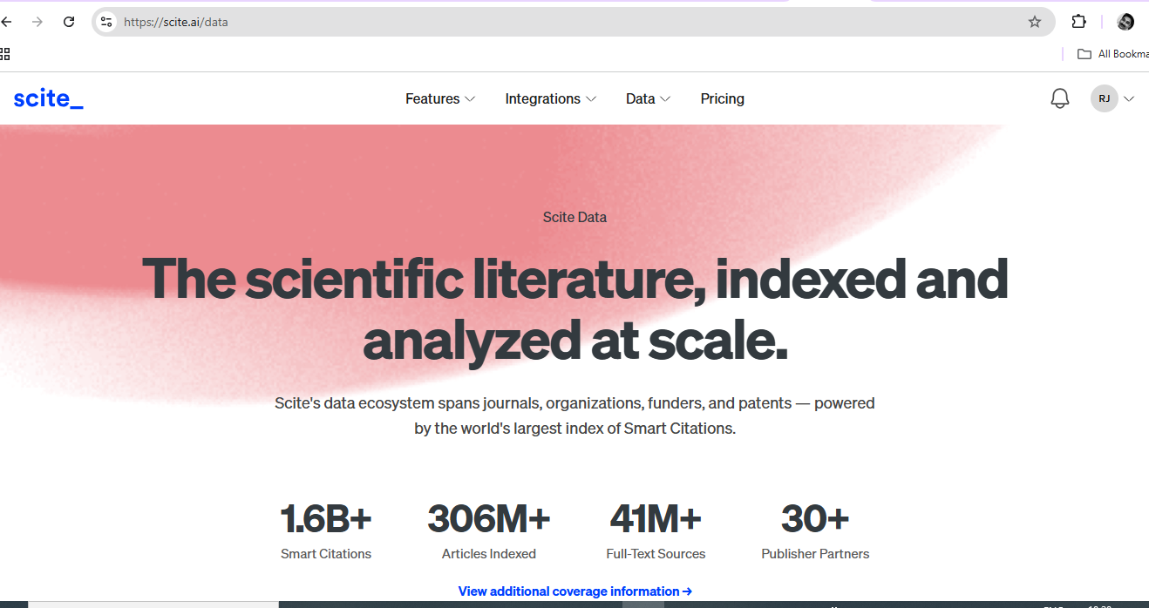

https://scite.ai/coverage
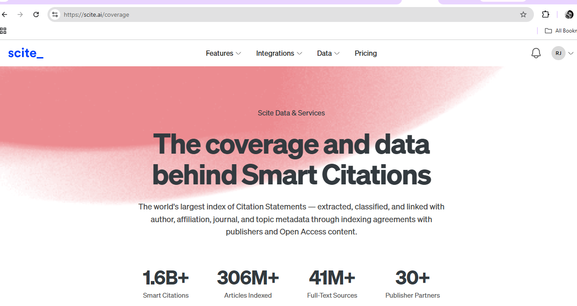

Raju Joseph - Regional Manager- South India
Informatics Publishing Ltd
E-mail: rmsouth@informaticsglobal.ai

